**Lab Practical #8:**

Study & Survey of Institute organization network infrastructure.

**Practical Assignment #8:**

1. **Identify type of network in your institute. Draw a design of network in your institute (Any Lab/Floor/Building).**

* **Lab No : C- 302**
* **Topology : Star Topology**

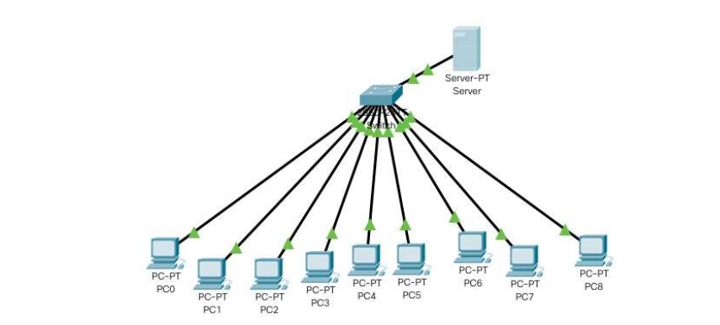

1. **List how many network devices and types of cable used and give its details.**

* Total No Of PC**:** **9**
* Total Number Of Switch**:** **1**
* Total Server**: DHCP Server**
* Types Of Cable**:** **Twisted Pair Cable**
* Connectors **:** **RJ-45**
* Network Type **: Lan**